Python Assignment 1: Data Structures - Strings & Tuples

Strings (Concatenation, Slicing and Other methods)
- String Concatenation
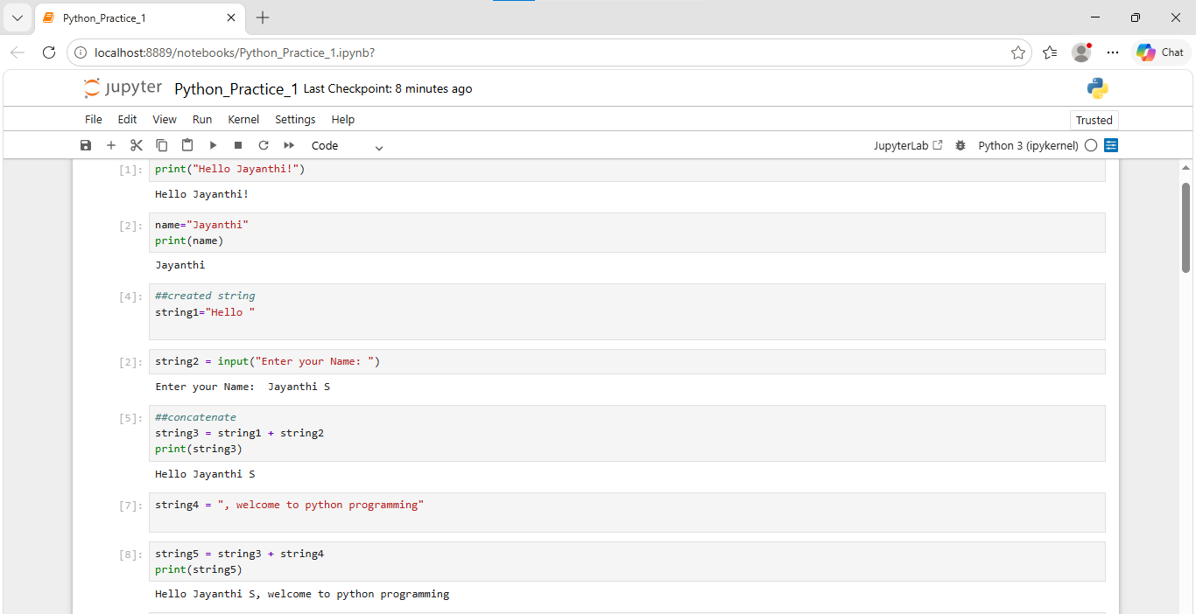

- String Slicing and Indexing
a. Print the first character of the string.
b. Print the last character of the string.
c. Print the first 5 characters of the string.
d. Print the last 11 characters of the string.
e. Print the string in reverse.
f. Use slicing and print the word “Python” from the existing string.
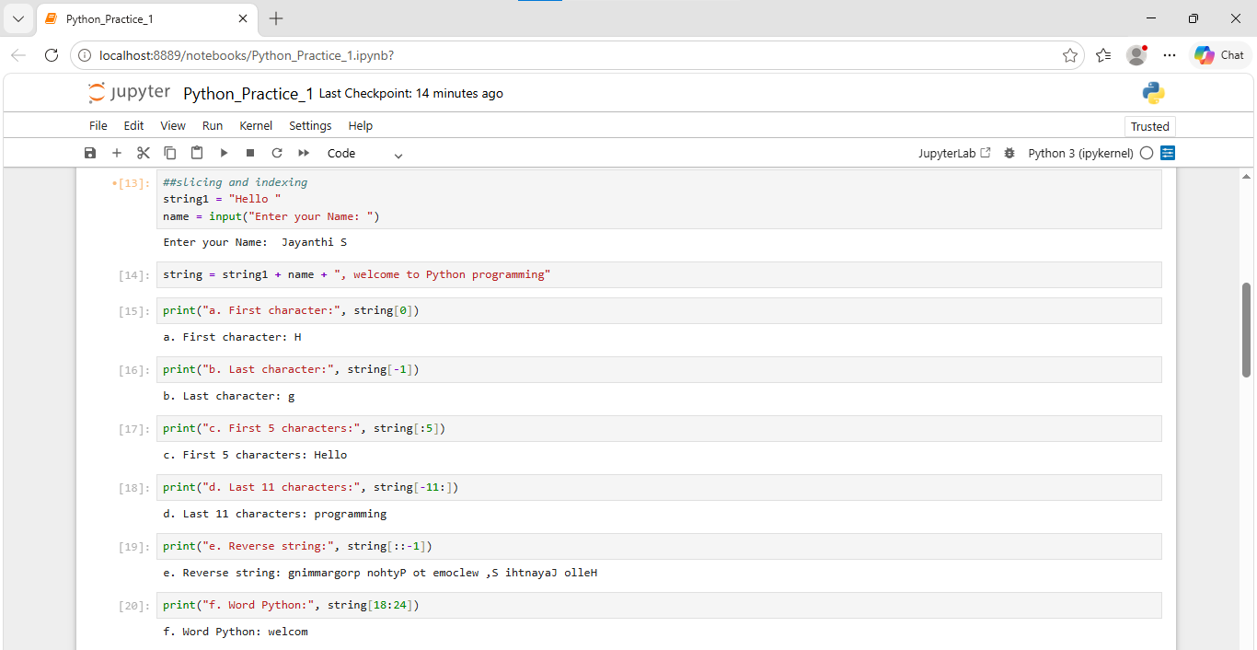

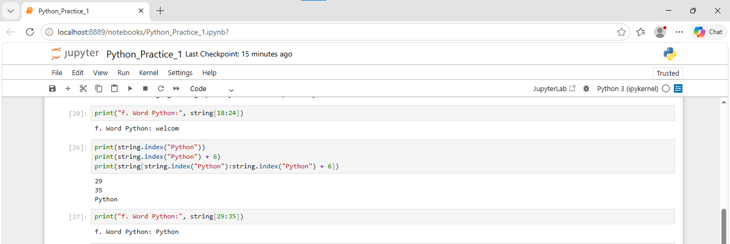

- String Methods:
a. Convert the sentence to uppercase.
b. Convert the sentence to lowercase.
c. Use Capitalize and return the sentence to the original input form.
d. Count the total number of occurrences of character ‘t’ in the string.
e. Replace all occurrences of “Python” with “Machine Learning” in the input string
strM = “Python beginner tutorial”

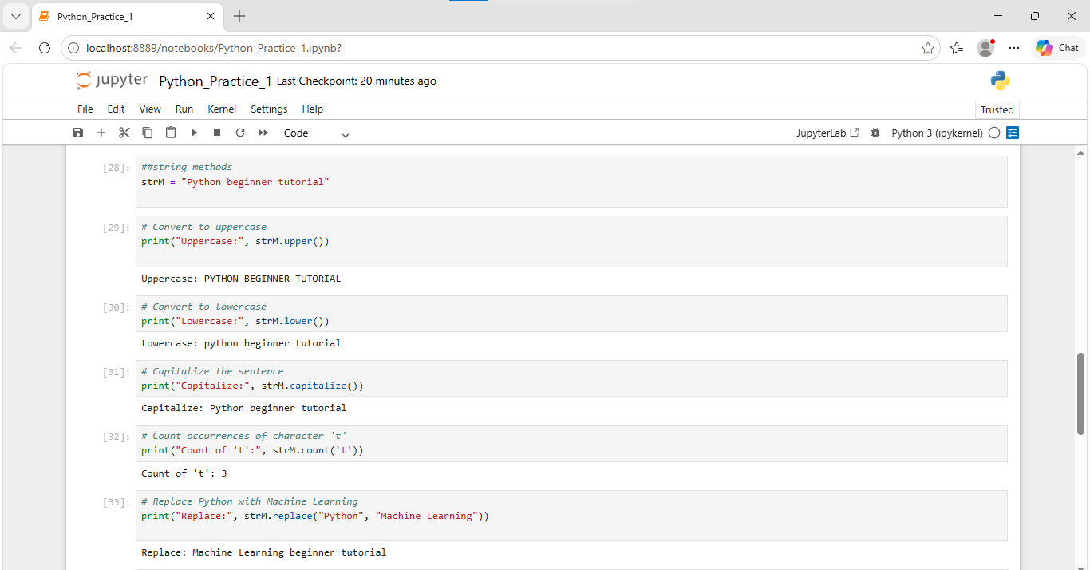

Tuples
a. Concatenate the two tuples and store it in “t_combine”
b. Repeat the elements of “t_combine” 3 times
c. Access the 3rd element from “t_combine”
d. Access the first three elements from “t_combine”
e. Access the last three elements from “t_combine”
